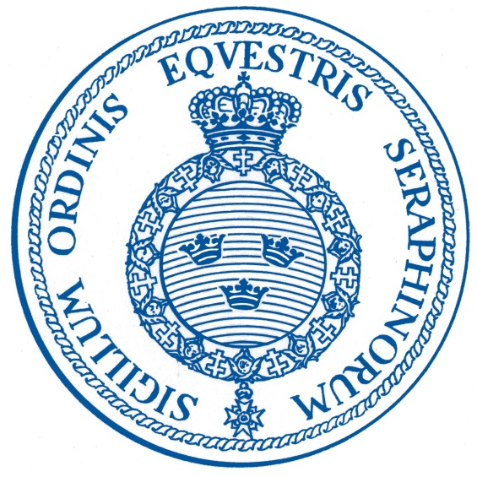

XIIth European Conference of Phaleristic Societies
Stockholm 25 to 27 May 2018

Host and organizer for the Conference is The Chancery of the Royal Orders of Knighthood (in Swedish Kungl. Maj:ts Orden). Delegates and partners will be accommodated, at recommended hotels of their own choice. A list with three hotels in the Old town is attached to the registration form with a map. The programme includes a Ladies’ programme on Saturday morning. Please note that no Bourse can be arranged on Sunday.

Please note the following important points, several of which have to do with the fact that the location on the conference is a royal residence and therefore under increased security, including armed guards. Free access to/from The Palace accordingly, as a rule, will not be possible. Registration as a participant takes place in the Western vault of the Western wing.

Name labels are issued for each participant on behalf of the Royal Palace and must be kept visible on Saturday. Note. Must be returned upon leaving the Royal Palace.

Dress code: Informal dress (tie requested) throughout except the Gala dinner; for the Gala dinner: Black tie (Dinner jacket)/Mess dress or Lounge suite and tie, official orders and deco-rations only. Please observe that phaleristic society awards to be worn only at receptions.

Programme

Friday 25 May

Afternoon: individual arrival/registration in the hotels.

18:00 to 20:30 ‘Meet and Greet’. Reception held in -------

Saturday 26 May

Breakfast at the hotels

Delegates’ programme
09:00 – 09:30 Registration of participants in the West wing of the Palace. Entrance from the
Outer Courtyard (to the right of the yellow sentry-box).
09:30 – 12:30 Presentations to be held in the CONFERENCE ROOM (Dining Hall of King Charles XV) of the Royal Palace,
- An introduction to the Swedish Awarding System and the birth of the Swedish Orders of Knighthood in 1748.
By Tom C. Bergroth, Museum of the Royal Orders of Knighthood.
- The evolution and manufacturing of badges of the Swedish Orders of Knighthood.
By Staffan Rosén, Vice Chancellor of the Swedish Royal Orders of Knighthood.
- The mission to Sweden in 1669 and the Order of the Garter to King Carl XIth.
By Stephen Patterson, Head of Collections Information Management, Royal Collection Trust, Windsor castle, England.
- The Doggersbank Medal (1781) and its Swedish recipients.
By George Sanders, Museum van de Kanselarij der Nederlandse Ordens, Netherlands
- Royal Commemorative Badges of Sweden.
By Tom C. Bergroth, Museum of the Royal Orders of Knighthood.

Ladies’ programme
09:30 – 11:30 GUIDED TOUR of The Royal Palace and the royal apartments. Two groups,
(English and French).

12:45 – 14:30 Lunch with the partners at Myntkrogen, Slottsbacken 6.

14:45 – 15:15 Presentation of the Museum of the Chancery of the Royal Orders by Tom C.
Bergroth in the CONFERENCE ROOM of the Royal Palace

Division of the delegates into two groups
1st group
15:30 – 16:00 Guided visit of the HALLS of the Orders of Knighthood.
16:00 – 16:30 Presentation of the Chancery of the Royal Orders.

2nd group
15:30 – 16:00 Presentation of the Chancery of the Royal Orders.
16:00 – 16:30 Guided visit of the HALLS of the Orders of Knighthood.

16:30 – 18:30 Free time

All delegates and partners
Dinner at Stadshuskällaren (The Cellar of the Town Hall), in the Town Hall, with the 2016 Nobel menu. The tables are laid with the Nobel service. Address: Hantverkaregatan 1.

18:15 Couch transportation from the hotels.
19:00 – 20:00 Drink reception.
20:00 – 24:00 Dinner.

Sunday 27 September

Breakfast at the hotels

All delegates and partners

10:00 – 11:30 The Riddarholmen Church
- Presentation of the heraldic tradition within the Order of the Seraphim.
By Tom C. Bergroth, Museum of the Royal Orders of Knighthood.

11:30 – 12:00 Guided tour of the Riddarholmen Church.

In the vestry a small exhibition: A Living Heraldic Tradition. The coats of arms of the Royal Order of the Seraphim.

12:00 – 12:30 Bus transportation to the Bååth Palace, Blasieholmsgatan 6.

12:45 – 15:30 Presentation of the Order of Charles XIIIth followed by reception with standing buffet offered by Tom C. Bergroth.

In the cloak room a small exhibition: The Royal Order of Carl XIIIth.

15:30 End of the XIIth Conference.

Date of update: 17.10.2017 TCB

